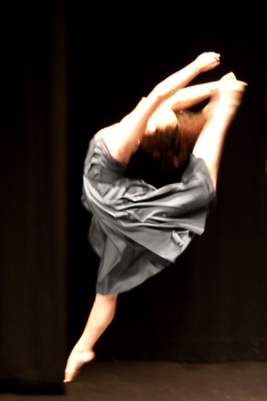



0274401079

***STUDIO’S: 46 VICTORIA AVENUE & 188 CUBA STREET, PALMERSTON NORTH***

TERM 2 NEWSLETTER 2021

What a wonderful start to 2021 we have had. It has been a relief not to have had the stress of C-19. Congratulations to all of our students who have performed at various events and done so well in the competitions during term 1.

**Miss Maxene** attended an RAD teacher’s ‘Pointe’ course in Wellington, she has enjoyed sharing what she learnt to her students.

Congratulations to the students who have been chosen for **Miss Kayla’s Hip Hop Junior Crew & Miss Emma’s performance & contemporary crew’s.** It has been exciting to see our competition students doing new dances and we have had some awesome results during term 1.

Once again, we had such an overwhelming response to our Free Workshops at the beginning of the term. Thank you to all of you who brought along your friends.

Congratulations to **Sashini Punchihewa** & **Malissa Sun** on their fabulous performance’s in the Boys high /Girls High school production of ‘Streakin’ thru the 70’s’.

I for one are very excited to go and see **Miss Emma & Rocky Rowland** in Chicago which is currently on. Don’t miss out!

Teacher’s look forward to helping NZAMD exam students with some extra holiday lessons during week 2.

All the best to those students dancing at ‘Esplanade day’, Manawatu and Wanganui competitions over the holiday period.

**Miss Maxene** is looking forward to judging dance competitions in Gisborne and Blenheim during term 2.

**Aladdin Jr– MYTH** A huge congratulations to **Lily McDonald, Emily Sutherland, Dorothy Lewis & Mikaela Christensen** who has been cast in this show. To be held in the July school holidays at the Globe Theatre.

Congratulations to **Shanel Penman** who has been asked to perform with the RNZB in Giselle 😊

**ADULT’S…** now it is your chance! Adult tap classes start Wednesday 5th of May, 7.15-8pm at 188 Cuba Street with Heidi. Come learn a new skill, get fit and have some fun!

IMPORTANT DATES:

**FRIDAY 16TH APRIL -Ballet exam entries due**

**MANAWATU COMPETITIONS 17th –22nd APRIL**

**NZAMD EXAM STUDENTS COACHING LESSONS 27th April – 1st May**

**WANGANUI COMPS 28th – 30th APRIL**

**7th MAY ISTD TAP/MODERN JAZZ EXAM ENTRIES CLOSING DATE**

**29TH JUNE- 9th JULY NZAMD HIP HOP & CONTEMPORARY & other genres EXAMS**

**Impact comps July**

**12th -16th JULY WINTER SCHOOL – VOCATIONAL BALLET STUDENTS**

**19th – 23rd JULY COACHING WEEK FOR ALL EXAM STUDENTS**

**AUGUST 4th -20th RAD BALLET EXAMS**

**SEPT ISTD EXAM PERIOD**

**September Holidays PNDA comps/Wanganui comps PACANZ**

**NATIONALS PN 20th -25th Oct**

**NZAMD Scholarship Awards WLGTN**

**RECITAL 26th & 27th Nov**

**CHRISTMAS BREAK-UP**

Term two will see some of our students sit their NZAMD exams. Extra classes/mocks will be scheduled where needed.

Please make sure you have warm crossovers etc to start classes off now we are into Autumn. All Ballet students need to bring Character shoes and skirts to class each week from term 2. All Ballet students should have their hair in a bun from Grade 3 please.

Parents please remember to keep up to date each term with the information posted on our website **www.maximumdance.co.nz** you can also find us on **facebook** which is regularly updated. At the end of each term the next term’s information is posted on the website with early bird fees available also.

**Miss** **Kristina, Miss Emma, Miss Emma Jane, Miss Eileen, Miss Elaine, Miss Kayla, Miss Malissa, Miss Alysha** and **Miss Maxene** wish you all a relaxing holiday. We look forward to seeing you back at dancing for term 2 from Monday the 3rd of May. Please note **NO** classes on **Queens Birthday** Mondaythe 14th of June.

Kind regards,

Miss Maxene & the teaching team at MDZ 😊