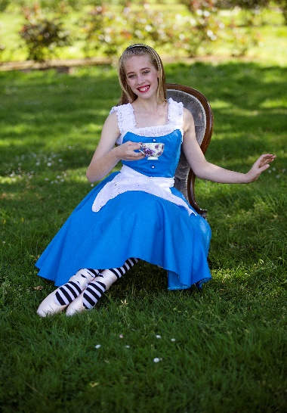

SU

PRINCIPAL: MAXENE JEFFARES-GREER PHONE: 0274 4010 79 OR 06 353 7759
STUDIO 1: 46 VICTORIA AVENUE, PALMERSTON NORTH.
STUDIO 2: 188 CUBA STREET, PN POSTAL ADDRESS: PO BOX 5506 PN

2017 AWARDS
ENCOURAGEMENT-
Olivia Tornquist, Meela Cole, Fai’ana Tuipulotu, Maia Smith, Danica ward, Kayla Adams, Jasmine Zhou, India Bos, Elaine Stichbury, Wilson Hannon
SMILEY AWARD –
Lily McDonald
OUTSTANDING:
TAP – Marian Sun
HIP HOP- Bart Andrews
JAZZ – Kayla Wilton
CONTEMPORARY- Brooke Pratt
BALLET-Ariana Buttar
OVERALL – Amy Lampp
EXAM TOP MARKS 2017
RAD BALLET- Ariana Buttar & Mikah BatachEl
ISTD TAP - Malissa Sun & Alexandra Pedley ISTD MODERN/JAZZ Malissa Sun, Maia Smith & Lily McDonald
NZAMD CONTEMPORARY Amy Lampp
HIP HOP- Marian Sun & Amy Lampp

TERM 1 NEWSLETTER 2018
A very warm welcome back to all new and existing students and families Congratulations to everyone who was involved in our 2017 recital of ‘Wonderland’ it was AWESOME! Thank you to all of the helpers and students who were involved in this vibrant show. It is so rewarding seeing the standard of dance continue to improve and we are lucky to work with such awesome students
Our exam results in 2017 were fantastic, especially our RAD vocational Ballet results. Huge congratulations to everyone whom sat an exam last year. The highlight of our year would have been Jo Berretts ‘Mariella’ contemporary troupe making it to the top 12 finalists in PACANZ! I am excited to see what we can accomplish this year.

ENROLMENT DAY –SECOND HAND UNIFORM SALE- FREE DANCE DISPLAYS: SATURDAY THE 3rd FEBRUARY 10AM-1pm STUDIO 1 - 46 VICTORIA AVENUE. Please bring along any friends you have that may be interested in starting dance to our enrollment day. Free dance displays will be running also. Existing students are automatically re-enrolled for 2018 once payment has been received. We have a lot of new classes on offer which are described over the page. Students training in more than one form of dance benefit greatly. It is suggested that from Grade 3 level two forms of dance are attended to help strengthen training. This really shows in the exam results also. As classes are filling up quickly please ensure you let Miss Maxene know your intentions for the year.

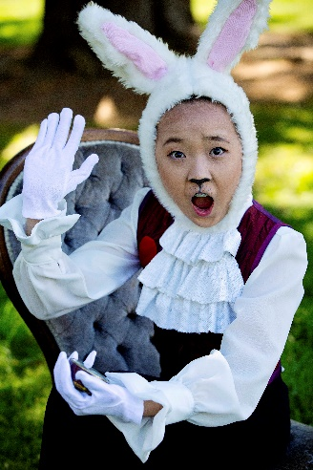
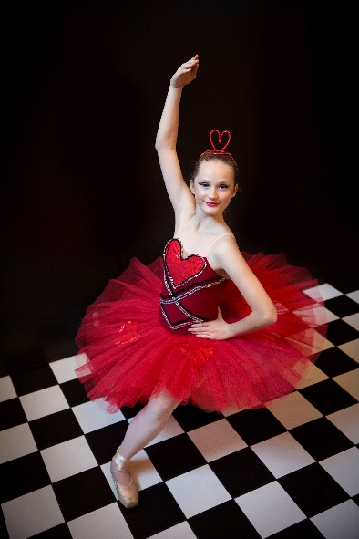
If you have any second hand gear that you would like to sell please drop this off on the 3rd between 10am and 10.30. Please name your items clearly and put your phone number and the price you would like on a slip in a plastic bag with your gear. If it does not sell you can collect it during term one, otherwise you will receive payment once classes have started back.
FREE WORKSHOPS/ TRY OUT A DANCE STYLE DAY – BRING YOUR FRIENDS!
SATURDAY THE 10TH OF FEBRUARY- 46 VICTORIA AVE
9AM 3 & 4 year olds
You will get to try out different forms of dance such as Ballet, tap, Jazz, Hip Hop, Contemporary & see some great dance displays…
9.45 5-8 year olds
10.45 9-11 year olds
12.15 12 years+
1.30 End
Term 1 dates: Vocationals (Seniors L4 hip hop/contemporary+, Inter Found Ballet, Tap & Modern+) will start the week of the 5th of February.
All other classes will begin the timetable on the website the week of the 12th of February. There will be classes the evening of Waitangi day. No classes on Good Friday or Easter Monday. Term one ends Saturday the 14th of April. Important dates list at end of newsletter…
2018 New Classes
TWINKLE TOES/FANCY FEET/DANCING DOTS– Beginners 3-5 year old classes. Fun imaginative dance including the basics of Ballet, Tap and Jazz. Using exciting props such as wands, scarves etc. Choose Monday, Thursday or Saturday class.
PRE PRIMARY/PRIMARY BALLET— For Pre Primary must be age 5 by the 31/01/18. More structured Ballet training with the opportunity to sit 1st assessment/exams later in the year. Ballet is the basis to all dance forms – and the best place to start. Choose from Thursday or Saturday class.
BEGINNERS (Primary) JAZZ/HIP HOP– From the age of 5, fun groovy class with funky moves. Opportunity to sit exams later in year. Thursday class.
HIP HOP—From the age of 9 a more focused Hip Hop class. As seen in music videos. Opportunity to sit exams.
BOYS ONLY! From the age of 5. Totally boy focused Jazz and Hip Hop. A highly energetic class —loads of fun!
TEEN TAP For those teens who want to give tap a go BEGINNERS TAP—From the age of 5. Learn to make awesome beats with your feet. Opportunity for exams.
INTRO CONTEMPORARY- 9years+ Flexibility, relaxation and control are some of the bonuses of this beautiful dance form.
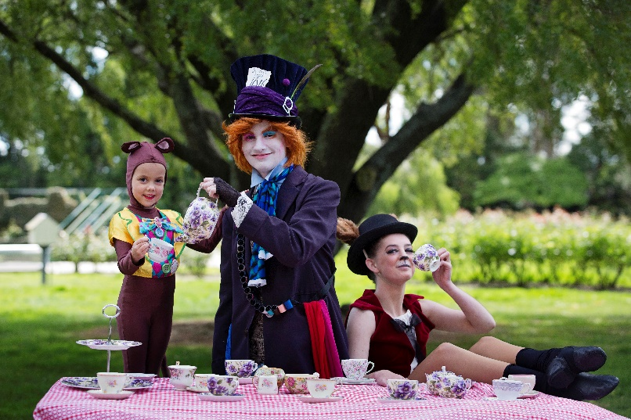
AND FOR THE ADULTS: JAZZ/HIP HOP With awesome motivational teachers. Get fit and learn a new skill – or return to your dance training after a break.

Uniform Requirements All items are available from SUGAR PLUM FAIRY SHOP—TERRACE END. Hair must be up for all classes except Contemporary at times. Hair must be in a bun for Ballet from Grade 4 upwards please. Crossover wraps are optional.
*TWINKLE TOES/FANCY FEET/DANCING DOTS-Own leotard and skirt or fairy dress. Ballet shoes needed.
*PRE PRIMARY/PRIMARY BALLET- Pink capped sleeved leotard (Chloe) and pink chiffon short wrap skirt with socks/ballet stockings and ballet shoes with elastic. *GRADE 1 AND 2 BALLET- Pale blue leotard (Aimee) with ballet stockings and ballet shoes with elastic. Character skirt (3 blue ribbons preferred) and low heeled character shoes. *GRADE 3 & 4 BALLET – MAUVE LEOTARD with ballet stockings and ballet shoes with ribbons. Character skirt and Cuban heeled Character shoes.
*GRADE 5 BALLET- Navy leotard (Faith) with ballet stockings and ballet shoes with ribbons. Character skirt and Cuban heeled Character shoes.
*HIGHER GRADES/ VOCATIONAL BALLET- Navy/black shoestring strapped leotard. Ballet flats and pointe shoes (you will be instructed on when to get your pointe shoes). Character gear for higher grades. Demi-pointes as Miss Maxene tells you.
MODERN JAZZ—Primary & Grade 1 – unitards.
Grade 2 - 6 New strappy backed leotard (purple, turquiose, royal blue or red—own choice) Black leggings & TAN Jazz shoes needed from Grade 3+
* Boys only – Personalised singlets can be purchased later in the year. Black shorts. Jazz shoes from Grade 3+ . Long black sport pants higher levels. * VOCATIONAL MODERN JAZZ— Leotard any style. Black nylon lycra leggings and TAN Jazz shoes. *BEGINNERS- GRADE 1 TAP—Own leotard and skirt. Socks and Tap shoes. *GRADE 2 TAP UPWARDS- Black leggings pants with own leotard/singlet top. Tap shoes—Oxford style from Grade 5 upwards. *CONTEMPORARY– Black leotard and leggings *HIP HOP 9+ CLASSES– Clothes that are easy to move in. Singlets can be purchased later in the year. No Jeans. Sneakers for Hip Hop.
PLEASE REMEMBER FURTHER INFORMATION CAN BE FOUND AT www.maximumdance.co.nz and Like us on fb for regular updates.

IMPORTANT DATES FOR 2018:
NB: dates are subject to change.
*Enrollment day/Second hand uniform sale: Saturday 3rd February 10am-1pm – Studio 1: 46 Victoria Ave.
* Contemporary Crew auditions 12 years +– Monday 29th January 6pm-7pm at Victoria Ave. Keep an eye on fb for further info
*Hip Hop crew auditions 11 years+ - Wednesday 31st January 6pm-7pm at Victoria Ave. Keep an eye on fb for further info
Term one starts:
*Vocationals timetable begins the 5th of February.
*Saturday 10th February – Workshops, 46 Victoria Ave.
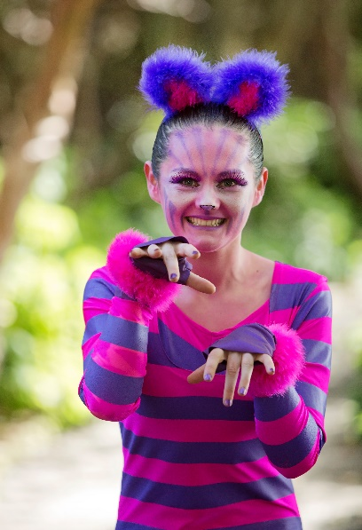
* 12th February will be first full week for all classes.
* Feb 23rd-25th PNDA comps
*4th March - Esplanade open day: Performers: Painting Cards, Lip gloss+
* March 23rd – 25th PNDA Ballet comps
No classes Good Friday or Easter Monday.
* ‘Grease’ show on at the Regent 6th – 14th of April
*13th April : NZAMD exams closing date
End of term one: Saturday 14th April
*Manawatu competitions - April
*NZAMD Contemporary and hip hop exam students extra practices during the holidays TBC.
Term two starts: 30th April
*RAD Vocational Ballet exam closing date: Friday 11th May
*RAD Grades Ballet exam closing date: Thursday 31st May
*NZAMD Contemporary and Hip hop exams: June 22nd - July 6th
*ISTD exam fees due TBA
*RAD Vocational Ballet students Winter school in Wellington – 9th – 13th July
*RAD grades, ISTD Tap and Modern examination coaching week/s: 16th- 21st July.
Term three starts: 23rd July
*RAD Vocational Ballet exams: 2nd – 4th August
*RAD Ballet Grade exams: 21st August-11th September
*ISTD Modern and Tap exams – 13th August – 23rd September
End of term -29th September
Term four starts: 15th of October
*Recital 30th November & 1st December
*Christmas break-up – 4th December

Please check the website for the new timetable & fees for 2018.
Looking forward to helping you reach for the stars!

Maxene Jeffares-Greer B.ED, DIP TCHG.
Registered teacher Royal Academy of Dancing, Imperial Society and NZAMD. AISTD Dip Modern, AISTD Dip Tap (Dist). Teaching Certificate RAD, Teaching Diploma RAD (Dist). Former International Professional dancer, National adjudicator.
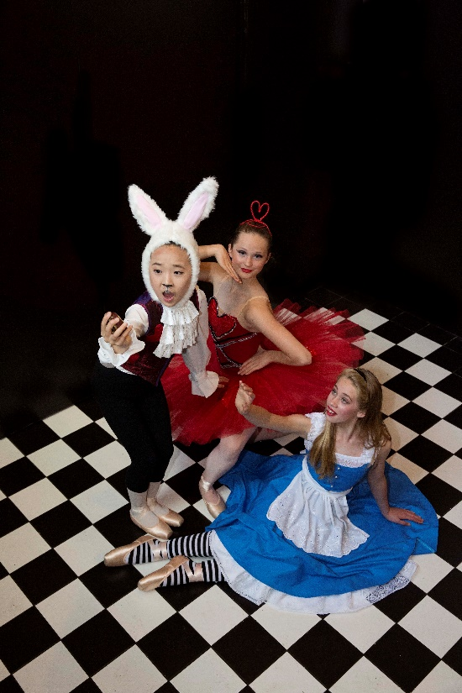
and staff—Chanel Saunders (Associate Dip AISTD) Jo Berrett (NZAMD Solo Jazz, Hip hop and Contemporary, G8 RAD) Kristina Beddis (Associate ISTD Tap-Dist) Emma Carey (NZAMD Solo Contemporary G8 RAD Ballet, Adv 1 ISTD Mod, Adv 1 RAD Ballet) Chantelle Christensen Adv 2 RAD Ballet Marian Sun Grade 8 RAD Ballet Dist. Inter ISTD Modern, L6 Contemp, NZAMD solo Hip Hop, Adv 2 ISTD Tap Dist India Bos Inter RAD Ballet, Inter ISTD Modern. Emma Jane Skinner RAD registered teacher. Bart Andrews Inter ISTD Modern, L5 Hip Hop. Kayla Wilton Inter ISTD Modern, Inter RAD Ballet, L5 Hip Hop & Contemporary. Madeline McHardy Inter ISTD Modern, Grade 7 RAD Ballet, Level 5 Contemporary.
Assistant and relieving Teachers: Bailee McConnell Inter Found RAD Ballet, Inter ISTD Modern. Georgia Morris-Rickard Inter Found RAD Ballet. Maddie Morris-Rickard Adv 1 ISTD Tap. Alia Robinson Grade 6 RAD Ballet.

