STUDIO: 46 VICTORIA AVENUE, PALMERSTON NORTH. POSTAL ADDRESS: PO BOX 5506, PN
TERM 3 NEWSLETTER 2017

IMP IMPORTANT DATES:
CONGRATULATIONS to all of wonderful dancers on the awesome achievements you have made so far this year! *PLEASE NOTE; Hip Hop & CONTEMPORARY exam student level’s go up in term 3. They will make a start on recital work this term.

MDZ CONTEMPORARY CREW NOMINATED FOR NZ NATIONALS!
Huge congratulations to dancer’s Kayla Wilton, Emma Carey, Amy White, Briony Milne, Joanna Berrett, Amy Lampp, Lily Bourne & Marian Sun who received a nomination to attend the NZ nationals for contemporary dance. With Miss Jo’s beautiful choreography and expertise, we are so excited for you!
Miss Chanel will be going on maternity leave in the middle of term 3. We are very excited to meet her twin baby girls later in the term! Thank you, Miss Chanel for the wonderful teaching you do – we wish you all the best. Miss Jo and Miss Kayla will be covering her classes over this time.
It was wonderful to see a group of our dancers support the PNDA Open classes, ‘Phoenix dance workshops’ and competitions around NZ throughout term 2. These events extend you and give you valuable experiences
All the best to the 12 girls attending Winter school in Wellington during the holidays. It is so exciting seeing our vocational Ballet student’s abilities develop further.
Miss Maxene is looking forward to judging in Whangarei in September.
JULY WINTER SCHOOL – VOCATIONAL BALLET STUDENTS
17-22ND JULY COACHING WEEK FOR ALL EXAM STUDENTS
AUGUST 1-5TH RAD VOCATIONAL BALLET EXAMS
AUGUST 22 – 12TH SEPT RAD GRADES
AUGUST 14- SEPT 24th ISTD EXAMS
PN COMPS 24TH- 28TH SEPT
PACANZ COMPETITION
20TH -22ND OCT
NZAMD AWARDS 27TH- 29TH OCT
^{DECEMBER 1ST & 2ND RECITAL}
^{DECEMBER 5TH WORKSHOPS}
^{DECEMBER 6TH – BREAK-UP}
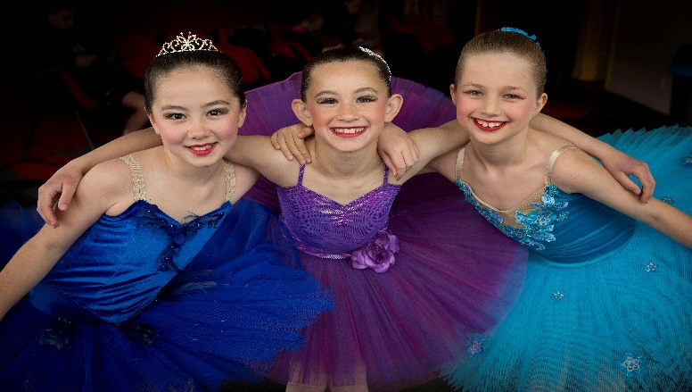
Special congratulations to Amy White who won an award in dance at PNGHS.
All of the teachers are looking forward to seeing students during the second week of the holidays for your exam preparation classes . Keep up the great practise at home
All the very best to students sitting exams in term 3. Once we have exam dates, we will update a timetable for the end of term 3 which will include the Recital reveal! Exciting!

Looking forward to helping you reach for the stars!
Maxene Jeffares-Greer B.ED, DIP TCHG.
Registered teacher Royal Academy of Dancing, Imperial Society and NZAMD. AISTD Dip Modern, AISTD Dip Tap (Dist). Teaching Certificate RAD, Teaching Diploma RAD (Dist). Former International Professional dancer
and staff— Chanel Saunders (AISTD), Kristina Beddis-McErlean (AISTD), Emma Carey, Madeline McHardy, Jo Berrett, Marian Sun, Chantelle Christiansen, Emma-Jane Skinner (RAD reg), Kayla Wilton, India Bos, Bailee McConnell

