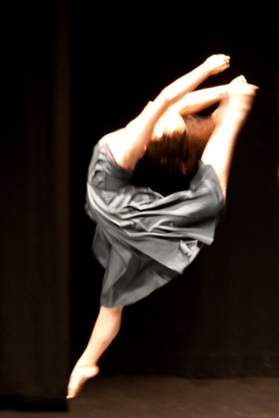



(06)353 7759

***STUDIO: 46 VICTORIA AVENUE, PALMERSTON NORTH. POSTAL ADDRESS: PO BOX 5506, PN***

TERM 2 NEWSLETTER 2016

IMPORTANT DATES:

**NZAMD EXAM STUDENTS COACHING LESSONS 26h – 29th April**

**PALMERSTON NORTH COMPETITIONS 17- 22nd APRIL**

**NEW PLYMOUTH COMPS 16th-19th APRIL**

**WANGANUI COMPS 27th – 29th APRIL**

**PHOENIX WORKSHOP 30th- 1st May**

**4th May RAD BALLET VOCATIONAL EXAMS CLOSING DATE**

**25th MAY RAD BALLET GRADES EXAMS CLOSING DATE**

**31st MAY ISTD MODERN/TAP EXAM ENTRIES DUE**

**19th JUNE PNDA CONCERT**

**22nd JUNE- 8TH JULY NZAMD HIP HOP & CONTEMPORARY EXAMS**

**11th- 15th JULY WINTER SCHOOL – VOCATIONAL BALLET STUDENTS**

**18th – 22nd JULY COACHING WEEK FOR ALL EXAM STUDENTS**

**AUGUST 1st – 6th RAD VOCATIONAL BALLET EXAMS**

**12TH AUGUST – 25TH SEPT ISTD EXAM PERIOD**

**AUGUST 23 - SEPT 13th RAD BALLET GRADE EXAMS**

**26th – 30th Sept PNDA comps**

**NOVEMBER 25th & 26th RECITAL**

What a fantastic start to the year we have had! We started off 2016 with ‘Sizzling Summer Dance Days’ holiday programme. This was such a wonderful experience and it was quite amazing to see how much our students learnt over the 3 days. We will definitely be offering this again next year☺

Congratulations to these students who have been chosen for **Miss Chanel’s MDZ Hip Hop Junior, Intermediate & National Hip Hop Crew & Miss Jo’s contemporary crew.** It has been exciting to see our competition students doing new dances and we have had some awesome results during term 1. Special congratulations to **MARIAN SUN** who has been nominated to attend the **New Zealand Tap dancing nationals** held in Palmerston North in October. This in an incredible achievement and we are all SO proud of you!!!

A huge Congratulations to Miss **EMMA CAREY** and **MARIAN SUN** who have both been chosen to perform in ‘CATS’ in August. We are all looking forward to seeing you shine on stage!

It is awesome to see our Adult hip hop/jazz class growing. These adult classes are for beginners or those returning to dance and are a whole lot of fun. Don’t be shy- come and give it a go☺ Miss Chanel is super lovely ☺

All the best to students who are performing in the Manawatu, Rotorua, New Plymouth and Wanganui Competitions during the holidays and participating at ‘Phoenix’ dance workshop. Miss Emma and Miss Chanel look forward to seeing many of you at their **NZAMD exam lessons in week 2 of the holidays**. Term two will see some of our students sit their NZAMD exams. Extra classes/mocks will be scheduled where needed. Miss Maxene and Miss Emma and Josh Rickard enjoyed the NZAMD contemporary course held in Wellington in term 1.

Many of the studio are looking forward to seeing the RNZB perform ‘The Wizard of Oz’ in June. Miss Maxene and Miss Chantelle are looking forward to attending professional development day with the RNZB in Wellington during the holidays- looking specifically at ‘Pas de deux’ work. Miss Maxene will also be judging in Auckland during term 2. It is great that so many of our vocational Ballet students are attending NZSOD Winter school. They will be doing some fundraising during term 2. Please help support them.

Please remember to keep up to date each term with the information posted on our website **www.maximumdance.co.nz** you can also find us on **facebook** which is regularly updated. At the end of each term the next term’s information is posted on the website with early bird fees available also. **Miss MacDonald, Miss** **Kristina**, **Miss Chanel, Miss Emma, Miss Jo, Miss Madeline** and **Miss Maxene** wish you all a relaxing holiday. We look forward to seeing you back at dancing for term 2 from Monday the 2nd of May. Please note **NO** classes on **Queens Birthday** Monday6th of June.

.

**Please**

*Looking forward to helping you reach for the stars!* **Maxene Jeffares-Greer B.ED, DIP TCHG.**

Registered teacher Royal Academy of Dancing, Imperial Society and NZAMD. AISTD Dip Modern, AISTD Dip Tap (Dist). Teaching Certificate RAD, Teaching Diploma RAD (Dist). Former International Professional dancer

**and staff—Jo Berrett (NZAMD Adv.** Jazz, **G8 RAD), Kristina Beddis (Adv.Tap-Dist) , Rachel Carey (NZAMD Adv.** Jazz, **G8 RAD), Chantelle Christensen, Glenn London and Olivia Toner**