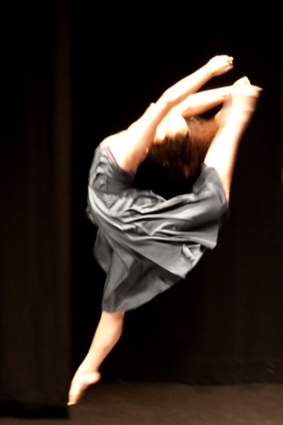



(06)353 7759

***STUDIO’S: 46 VICTORIA AVENUE & 188 CUBA STREET, PALMERSTON NORTH***

IMPORTANT DATES:

**NZAMD EXAM STUDENTS COACHING LESSONS 26h – 29th April**

**PALMERSTON NORTH COMPETITIONS 18- 23rd APRIL**

**NEW PLYMOUTH COMPS 20th-24th APRIL**

**WANGANUI COMPS 26th – 29th APRIL**

**PHOENIX WORKSHOP 29th-30th April**

**12th May RAD BALLET VOCATIONAL EXAMS CLOSING DATE**

**31st MAY RAD BALLET GRADES EXAMS CLOSING DATE**

**ISTD MODERN/TAP EXAM ENTRIES DUE TBC**

**22nd JUNE- 8TH JULY NZAMD HIP HOP & CONTEMPORARY EXAMS**

**10th- 15th JULY WINTER SCHOOL – VOCATIONAL BALLET STUDENTS**

**17th – 22nd JULY COACHING WEEK FOR ALL EXAM STUDENTS**

**AUGUST 2nd – 5th RAD VOCATIONAL BALLET EXAMS**

**AUGUST – 30TH SEPT ISTD EXAM PERIOD**

**AUGUST 22 - SEPT 30th RAD BALLET GRADE EXAMS**

**30th Sept PNDA comps/Wanganui comps**

**27th- 29th OCTOBER NZAMD Scholarship Awards in Auckland**

**NATIONALS PN OCTOBER**

**1st-2nd DEC RECITAL**

TERM 2 NEWSLETTER 2017

Maximum Dance Zone has had a brilliant start to 2017. It has been great to welcome back our lovely dance family and to see lots of new faces join in the fun too 😊 It is pleasing to see the work that has been covered in term 1.

**Miss Maxene** started 2017 with an ‘Advanced 1 Ballet’ and ‘Inside the exam’ teacher’s course in Wellington. It is so essential to keep teaching standards high.

Congratulations to the students who have been chosen for **Miss Chanel’s MDZ Hip Hop Crew & Miss Jo’s contemporary crew.** It has been exciting to see our competition students doing new dances and we have had some awesome results during term 1.

We had a wonderful ‘Pointe’ workshop for senior Ballet students and Mum’s. It is so wonderful to see many of our senior girls reaching this exciting stage – something they have strived for, for so long.

A huge Congratulations to Miss **EMMA CAREY** and Miss **MARIAN SUN** who have both been chosen to perform in ‘CHORUS LINE’ in the April school holiday’s. We are all looking forward to seeing you shine on stage!

Well done to our polished performers at Esplanade open day. Great work!

It was awesome to see so many of students take up the opportunity to attend the **RNZB** open classes. Such a positive and inspiring experience for all.

All the best to students who are performing in the Manawatu, Rotorua, New Plymouth and Wanganui Competitions during the holidays and participating at ‘Phoenix’ dance workshop. Miss Emma and Miss Chanel look forward to seeing many of you at their **NZAMD exam lessons in week 2 of the holidays**. Term two will see some of our students sit their NZAMD exams. Extra classes/mocks will be scheduled where needed.

Miss Maxene and Miss Chantelle are looking forward to attending professional development day with the **RNZB** in Wellington during the holidays- looking specifically at ‘Female Ballet technique’. It is great that so many of our vocational Ballet students are attending **NZSOD Winter school**. They will be doing some fundraising during term 2. Please help support them.

Huge congratulations to **MISS CHANEL** & Luke as they are expecting TWINS!!! 😊 😊 So exciting, we wish you all the very best!

At Maximum Dance Zone it is wonderful to see many of our senior students stepping up into teaching positions. I am very proud of you and the wonderful teaching staff that we have – keep up the great work.

Parents please remember to keep up to date each term with the information posted on our website **www.maximumdance.co.nz** you can also find us on **facebook** which is regularly updated. At the end of each term the next term’s information is posted on the website with early bird fees available also.

**Miss** **Kristina**, **Miss Chanel, Miss Emma, Miss Jo, Miss Madeline, Miss Bailee, Miss Kayla, Miss Brie, Miss Marian** and **Miss Maxene** wish you all a relaxing holiday. We look forward to seeing you back at dancing for term 2 from Monday the 1st of May. Please note **NO** classes on **Queens Birthday** Mondaythe 5th of June.

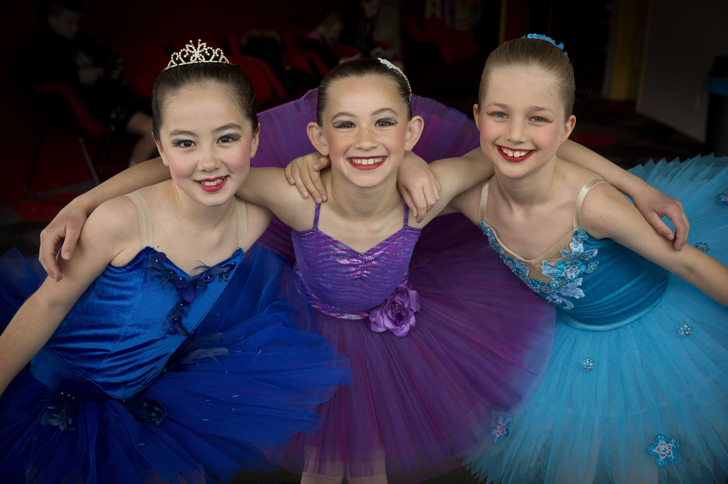

Photo Cred: Faith Sunterland

*Looking forward to helping you reach for the stars!* **Maxene Jeffares-Greer B.ED, DIP TCHG.**

Registered teacher Royal Academy of Dancing, Imperial Society and NZAMD. AISTD Dip Modern, AISTD Dip Tap (Dist). Teaching Certificate RAD, Teaching Diploma RAD (Dist). Former International Professional dancer

**and staff—Jo Berrett (NZAMD Adv.** Jazz, **G8 RAD), Kristina Beddis (Adv.Tap-Dist) , Rachel Carey (NZAMD Adv.** Jazz, **G8 RAD), Chantelle Christensen, Glenn London and Olivia Toner**