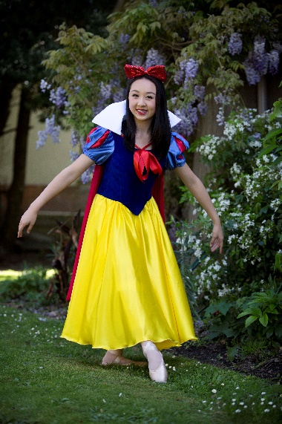

SU

PRINCIPAL: MAXENE JEFFARES-GREER PHONE: 0274 4010 79 OR 06 353 7759
STUDIO 1: 46 VICTORIA AVENUE, PALMERSTON NORTH.
STUDIO 2: 188 CUBA STREET, PN POSTAL ADDRESS: PO BOX 5506 PN

2016 AWARDS
ENCOURAGEMENT-
Caitlyn Tornquist, Joshua Rickard, Ivy Yang, Hannah Hudson, Amy Su, Lauren Janssen
SMILEY AWARD –
Mikah BataChel
OUTSTANDING:
TAP –Emma-Katte Johnston
HIP HOP- Brianna Searle
JAZZ – Amy Lampp
CONTEMPORARY- Amy White
BALLET-Emily Hannon
OVERALL 3 DISCIPLINES-
Marian Sun
EXAM TOP MARKS 2016
RAD BALLET- Ariana Buttar
ISTD TAP - Marian Sun ISTD MODERN/JAZZ Ashlyn Rowland & Sarah Rynhart
NZAMD CONTEMPORARY Amy White
HIP HOP- Brie Searle, Kayla Wilton, Marian Sun & Amy Lampp

TERM 1 NEWSLETTER 2017
A very warm welcome back to all new and existing students and families Congratulations to everyone who was involved in our 2016 recital of ‘Snow White’ it was BEAUTIFUL! Thank you to all of the helpers and students who were involved in this vibrant show. It is so rewarding seeing the standard of dance continue to improve and we are lucky to work with such awesome students
Our exam results in 2016 were fantastic, especially our RAD vocational Ballet results. Huge congratulations to everyone whom sat an exam last year. I am excited to see what we can accomplish this year.

ENROLMENT DAY’S –SECOND HAND UNIFORM SALE- FREE DANCE DISPLAYS: SATURDAY THE 28TH JANUARY 10AM-12NOON & SATURDAY THE 4th FEBRUARY 10AM – 1PM STUDIO 1 - 46 VICTORIA AVENUE. Please bring along any friends you have that may be interested in starting dance to our enrolment day. Free dance displays will be running also. Existing students are automatically re-enrolled for 2017 once payment has been received. We have a lot of new classes on offer which are described over the page. Students training in more than one form of dance benefit greatly. It is suggested that from Grade 3 level two forms of dance are attended to help strengthen training. This really shows in the exam results also. As classes are filling up quickly please ensure you let Miss Maxene know your intentions for the year.

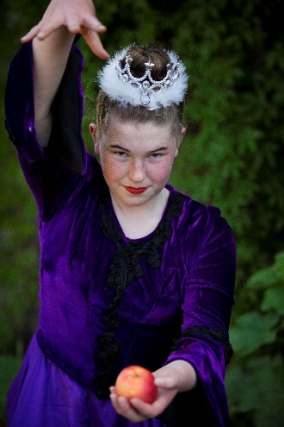
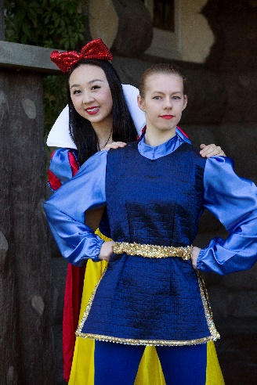
If you have any second hand gear that you would like to sell please drop this off on the 28th between 10am and 10.30. Please name your items clearly and put your phone number and the price you would like on a slip in a plastic bag with your gear. If it does not sell you can collect it during term one, otherwise you will receive payment once classes have started back.
Term 1 dates: Vocationals (Seniors L4 hip hop/contemporary+, Inter Found Ballet, Tap & Modern+) will start the week of the 30th of January. All junior classes will begin the timetable on the website the week of the 7th of February. There will be classes the evening of Waitangi day. No classes on Good Friday or Easter Saturday. Term one ends Thursday the 13th of April.
2017 New Classes
TWINKLE TOES/FANCY FEET/DANCING DOTS– Beginners 3-5 year old classes. Fun imaginative dance including the basics of Ballet, Tap and Jazz. Using exciting props such as wands, scarves etc. Choose Monday, Thursday or Saturday class.
PRE PRIMARY/PRIMARY BALLET— For Pre Primary must be age 5 by the 01/01/17. More structured Ballet training with the opportunity to sit 1st assessment/exams later in the year. Ballet is the basis to all dance forms – and the best place to start. Choose from Monday or Saturday class.
BEGINNERS (Primary) JAZZ/HIP HOP– From the age of 5, fun groovy class with funky moves. Opportunity to sit exams later in year.
HIP HOP—From the age of 9 a more focused Hip Hop class. As seen in music videos. Opportunity to sit exams.
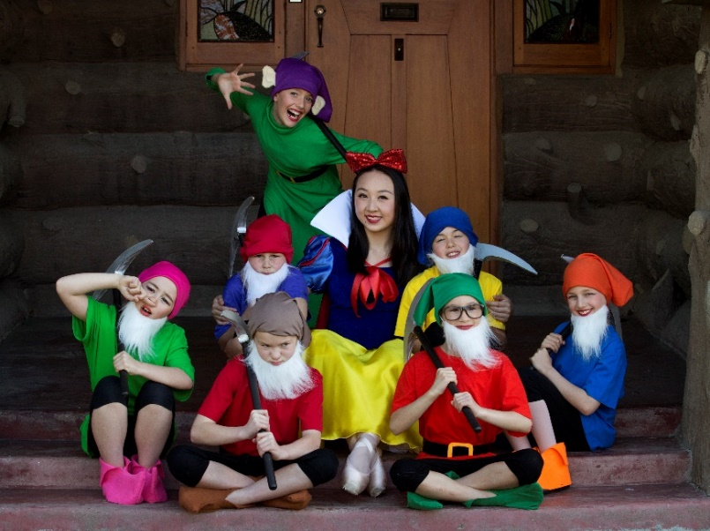
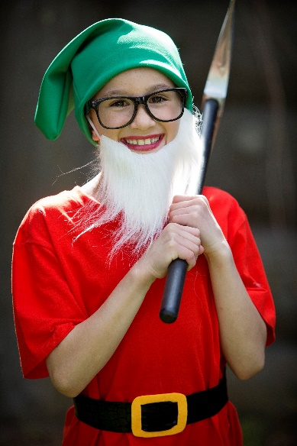
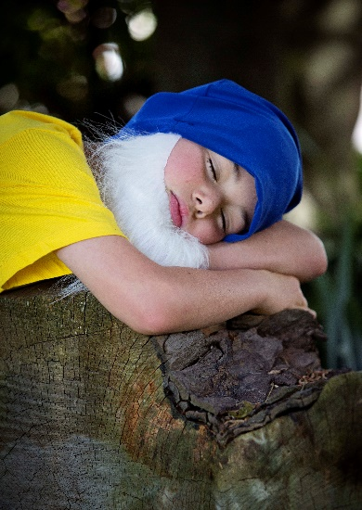
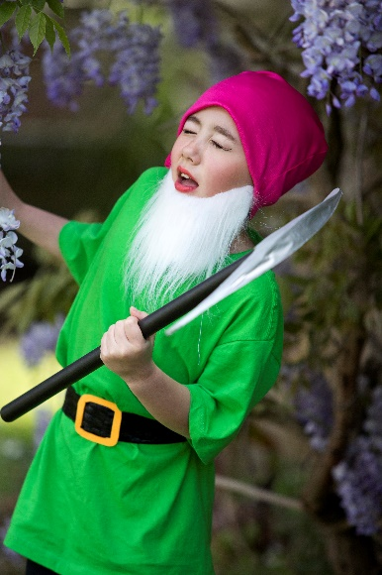
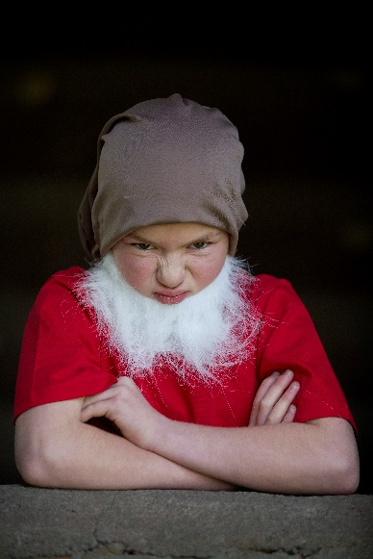
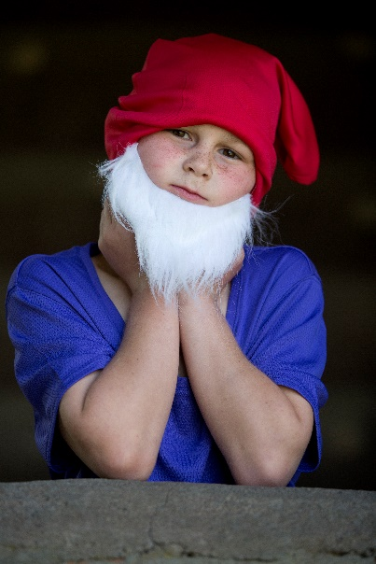
BOYS ONLY! From the age of 5. Totally boy focused Jazz and Hip Hop. A highly energetic class —loads of fun! TEEN TAP For those teens who want to give tap a go BEGINNERS TAP—From the age of 5 . Learn to make awesome beats with your feet. Opportunity for exams. INTRO CONTEMPORARY- 9years+ Flexibility, relaxation and control are some of the bonuses of this beautiful dance form. STRETCH, LEAP & SPIN (SLS)– All vocational students will receive this as an extra conditioning class free of charge. Opportunity to sit an exam in term 2. AND FOR THE ADULTS: JAZZ/HIP HOP With awesome motivational teachers. Get fit and learn a new skill – or return to your dance training after a break. Uniform Requirements All items are available from SUGAR PLUM FAIRY SHOP—TERRACE END. Hair must be up for all classes except Contemporary at times. Hair must be in a bun for Ballet from Grade 4 upwards please. Crossover wraps are optional. *TWINKLE TOES/FANCY FEET/DANCING DOTS-Own leotard and skirt or fairy dress. Ballet shoes needed. *PRE PRIMARY/PRIMARY BALLET- Pink capped sleeved leotard (Chloe) and pink chiffon short wrap skirt with socks/ballet stockings and ballet shoes with elastic. *GRADE 1 AND 2 BALLET- Pale blue leotard (Aimee) with ballet stockings and ballet shoes with elastic. Character skirt (3 blue ribbons preferred) and low heeled character shoes. *GRADE 3 & 4 BALLET – NEW MAUVE LEOTARD with ballet stockings and ballet shoes with ribbons. Character skirt and Cuban heeled Character shoes.
*GRADE 5 BALLET- Navy leotard (Faith) with ballet stockings and ballet shoes with ribbons. Character skirt and Cuban heeled Character shoes.
*HIGHER GRADES/ VOCATIONAL BALLET- Navy/black shoestring strapped leotard. Ballet flats and pointe shoes (you will be instructed on when to get your pointe shoes). Character gear for higher grades. Demi-pointes as Miss Maxene tells you.
MODERN JAZZ—Primary & Grade 1 – unitards.
Grade 2+New strappy backed leotard (purple, turquiose, royal blue or red—own choice) Black leggings & Jazz shoes needed from Grade 3+
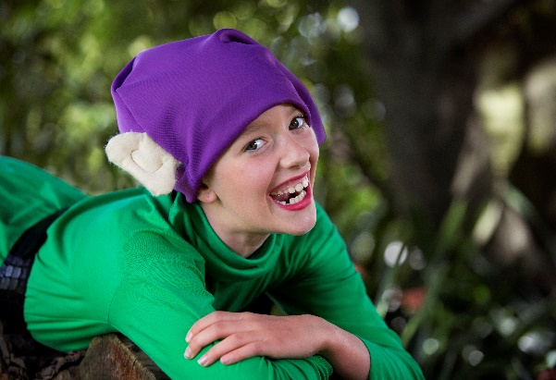
* Boys only – Personalised singlets can be purchased later in the year. Black shorts. Jazz shoes from Grade 3+ . Long black sport pants higher levels. *GRADE 4- 6 AND VOCATIONAL MODERN JAZZ— Black leotard any style. Black nylon lycra leggings and black Jazz shoes. *BEGINNERS- GRADE 1 TAP—Own leotard and skirt. Socks and Tap shoes. *GRADE 2 TAP UPWARDS- Black bootleg pants with own leotard/singlet top. Tap shoes—Oxford style from Grade 5 upwards. *CONTEMPORARY– Black leotard and leggings *HIP HOP 9+ CLASSES– Clothes that are easy to move in. Singlets can be purchased later in the year. No Jeans. Sneakers for Hip Hop.
PLEASE REMEMBER FURTHER INFORMATION CAN BE FOUND AT www.maximumdance.co.nz and Like us on fb for regular updates.
IMPORTANT DATES FOR 2017:
NB: dates are subject to change. SS= Selected students.
*Enrolment day/Second hand uniform sale: Saturday 28th of January 10am- 12noon & Saturday 4th February 10am-1pm – Studio 1: 46 Victoria Ave.
Term one starts:
*Vocationals timetable begins the 30th of January.
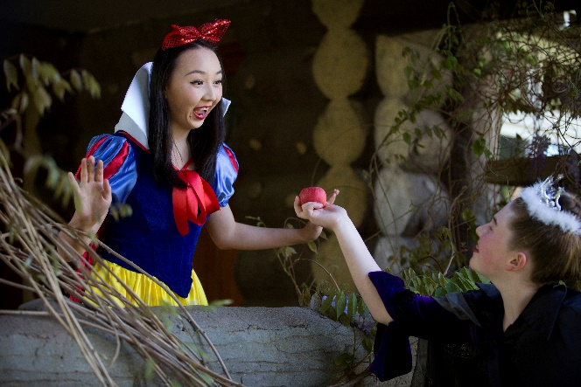
* 6th February will be first full week for all classes.
*19th February - Esplanade open day: Performers: ‘One’, Heigh Ho, I’m wishing, Poreotics.
April 24th-26th Manawatu Competitions
No classes Good Friday or Easter Saturday.
*13th April : NZAMD exams closing date
End of term one: Thursday 13th April.
*Manawatu competitions -
*NZAMD Contemporary and hip hop exam students extra practices during the holidays TBC.
Term two starts: 1st May
*RAD Vocational Ballet exam closing date: Friday 12th May
*RAD Grades Ballet exam closing date: Wednesday 31st May
*NZAMD Contemporary and Hip hop exams: June 22nd - July 8th
*ISTD exam fees due TBA
*RAD Vocational Ballet students Winter school in Wellington – 10th – 14th July
*RAD grades, ISTD Tap and Modern examination coaching week/s: 17th- 22nd July.
Term three starts: 24th July
*RAD Vocational Ballet exams: 2nd – 5th August
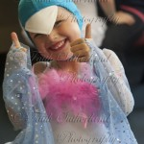
*RAD Ballet Grade exams: 22nd August-12th September
*ISTD Modern and Tap exams – dates tba
End of term -29th September
Term four starts: 16th of October
*Recital 1st & 2nd December
*Free Workshop’s – 5th December
*Christmas break-up – 6th December

Please check the website for the new timetable & fees for 2017.
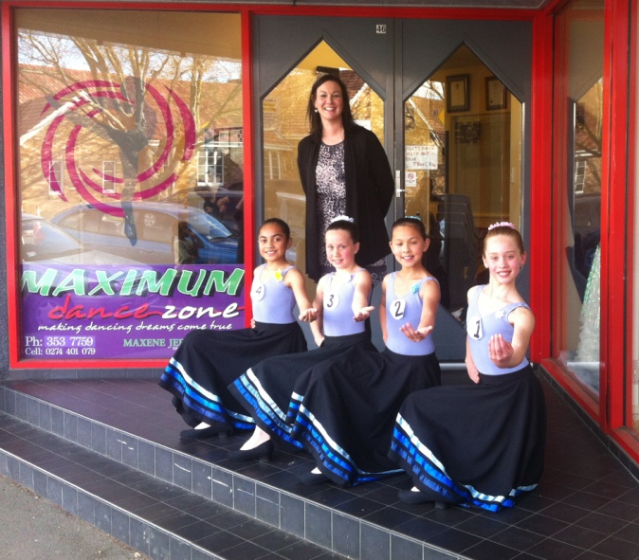
Looking forward to helping you reach for the stars!

Maxene Jeffares-Greer B.ED, DIP TCHG.
Registered teacher Royal Academy of Dancing, Imperial Society and NZAMD. AISTD Dip Modern, AISTD Dip Tap (Dist). Teaching Certificate RAD, Teaching Diploma RAD (Dist). Former International Professional dancer, National adjudicator.

and staff—Chanel Saunders (Associate Dip AISTD) Jo Berrett (NZAMD Solo Jazz, Hip hop and Contemporary, G8 RAD) Kristina Beddis (Associate ISTD Tap-Dist) Emma Carey (NZAMD Solo Contemporary G8 RAD Ballet, Adv 1 ISTD Mod, Adv 1 RAD Ballet) Chantelle Christensen Adv 2 RAD Ballet Marian Sun Grade 8 RAD Ballet Dist. Intermediate ISTD Modern, L5 Contemp, Hip Hop L6, Adv 2 ISTD Tap Dist
Assistant and relieving Teachers: Brianna Searle Hip Hop L6, Inter ISTD Modern. Contemp L5, India Bos Inter Found RAD Ballet, Inter ISTD Modern. Bailee McConnell Inter Found RAD Ballet, Inter ISTD Modern.

