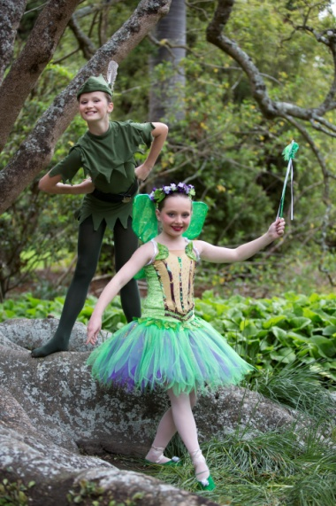

**SU**

***PRINCIPAL: MAXENE JEFFARES-GREER PHONE: 0274 4010 79 OR 06 353 7759***

***STUDIO 1: 46 VICTORIA AVENUE, PALMERSTON NORTH.***

***STUDIO 2: 188 CUBA STREET, PN POSTAL ADDRESS: PO BOX 5506 PN***

**2015 AWARDS**

***ENCOURAGEMENT-***

Caitlyn Tornquist, Shaina Jeffrey, Briony Milne, Nina Burch, Brooke Pratt, Ariana Buttar, Alana Holroyd, Gabi King, Alysha Smith, Amy White, Amy Lampp, Daniel Fletcher

**SMILEY AWARD –**

Georgia Morris-Rickard

**OUTSTANDING:**

***TAP –***Lauren Holroyd

***HIP HOP-*** Brianna Searle

***JAZZ –*** Kayla Wilton

***CONTEMPORARY-*** Amy Srichantra

***BALLET-***

Emily Hannon

***OVERALL 3 DISCIPLINES-***

Marian Sun

**EXAM TOP MARKS 2015**

***RAD BALLET-*** Marian Sun & Grace Zimmerman

***ISTD TAP -*** *Alana Holroyd 86%* ***ISTD MODERN/JAZZ*** *Amelia O’Brien 91%*

**NZAMD CONTEMPORAR Y** Emma Carey

**HIP HOP-** Brie Searle

TERM 1 NEWSLETTER 2016

2016 is going to be year full of wonderful dancing!☺ A very warm welcome to our new families ☺ Congratulations to everyone who was involved in our 2015 recital of ‘Peter Pan’ it was AWESOME! Thank you to all of the helpers and students who were involved in this vibrant show. It is so rewarding seeing the standard of dance continue to improve and we are lucky to work with such awesome students☺ Be sure to check out the beautiful photo’s Leilani Hayes has taken for us. Ordering information can be found on our fb page.

Our exam results in 2015 were truely outstanding, especially our RAD Ballet results. Huge congratulations to everyone whom sat an exam last year. I am excited to see what we can accomplish this year. 2016 will start of with our:

C:\Users\Max\AppData\Local\Microsoft\Windows\Temporary Internet Files\Content.IE5\N9S58UDZ\MC900171843[1].wmf‘SIZZLING SUMMER DANCE DAYS’ Beginners to Advanced dancers can learn some new skills Jan 27th, 28th and 29th 8.45-3pm with our versatile teachers... Just when your children are starting to get bored with the school holidays or looking for holiday care - let us entertain and up skill them. Please email me if you would like to attend. Our workshop will end with an exciting performance showing what they have learnt on the Friday. Enrolment form on website www.maximumdance.co.nz

ENROLMENT DAY –SECOND HAND UNIFORM SALE- FREE DANCE DISPLAYS: SATURDAY THE 30th JANUARY 10AM – 1PM STUDIO 1 - 46 VICTORIA AVENUE. Please bring along any **friends** you have that may be interested in starting dance to our enrolment day. **Free dance displays** will be running also. Existing students are automatically re-enrolled for 2016 once payment has been received. We have a lot of **new classes** on offer which are described over the page. ***Students training in more than one form of dance benefit greatly.*** It is suggested that from **Grade 3 level two forms** of dance are attended to help strengthen training. This really shows in the exam results also. As classes are filling up quickly please ensure you let Miss Maxene know your intentions for the year.

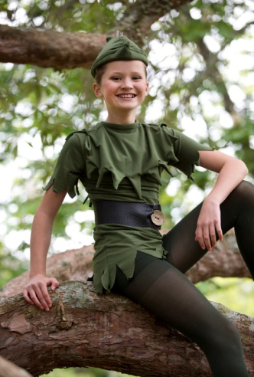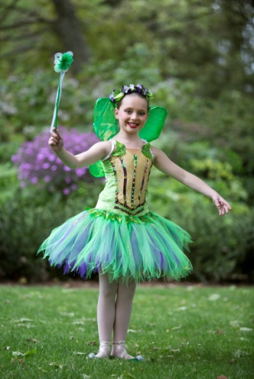If you have any **second hand gear** that you would like to sell please drop this off on the 30th between10am and 10.30. Please name your items clearly and put your phone number and the price you would like on a slip in a plastic bag with your gear. If it does not sell you can collect it during term one, otherwise you will receive payment once classes have started back.

**MDZ HIP HOP CREW** **AUDITIONS** FOR THESE WILL BE HELD ON WEDNESDAY 3RD OF FEBRUARY. STUDIO 2 : 188 CUBA STREET. 4.15-5PM JUNIORS 8- 10 YRS, 6pm – 6.45 SENIORS 11 +. To be eligible you must attend at least 1 class at MDZ. IF SUCCESSFUL YOUR CREW WILL TRAIN WEEKLY AND COMPETE/PERFORM AT DIFFERENT FUNCTIONS THROUGHOUT THE YEAR.

Miss Maxene, Miss Jo and Miss Emma are looking forward to professional development at a Contemporary workshop in Wellington during term 1. We look forward to passing on what we learn to our Contemporary students.

Term 1 dates: Vocationals will start the week of the 1st of February (timetable will be emailed to you) all other classes will begin the timetable on the website the week of the 8th of February. There **will** be classes the evening of Waitangi day. No classes on Good Friday or Easter Monday. Term one ends the 16th of April.

**2016 New Classes**

***TWINKLE TOES/FANCY FEET/DANCING DOTS***– Beginners 3-5 year old classes. Fun imaginative dance including the basics of Ballet, Tap and Jazz. Using exciting props such as wands, scarves etc.

***PRE PRIMARY/PRIMARY BALLET*—** For Pre Primary must be age 5 by the **01/01/16.** More structured Ballet training with the opportunity to sit 1st assessment/exams later in the year. **Ballet is the basis to all dance forms – and the best place to start**.

***BEGINNERS (Primary) JAZZ/HIP HOP*–** From the age of 5, fun groovy class with funky moves. Opportunity to sit exams later in year.

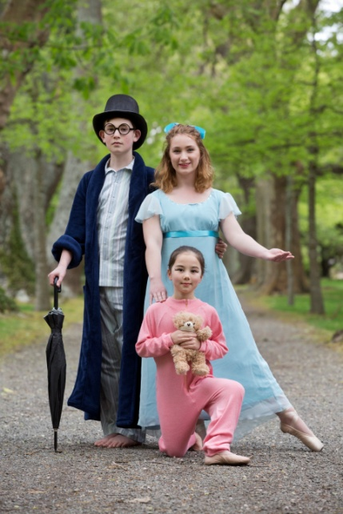**HIP HOP—**From the age of 9 a more focused Hip Hop class. As seen in music videos. Opportunity to sit exams.

**BOYS ONLY!** From the age of 5. Totally boy focused Jazz and Hip Hop. A highly energetic class—loads of fun! **BEGINNERS TAP—**From the age of 5. Learn to make awesome beats with your feet. Opportunity for exams. .

**JUNIOR CONTEMPORARY-**  9years+ Flexibility, relaxation and control are some of the bonuses of this beautiful dance form.

**STRETCH, LEAP & SPIN (SLS)–** All vocational students will receive this as an extra conditioning class free of charge. Opportunity to sit an exam in term 2.

***AND FOR THE ADULTS:* JAZZ/HIP HOP** 6 week courses with awesome motivational teachers. Get fit and learn a new skill – or return to your dance training after a break.

***If you have a request for a class please let Miss Maxene know and she may be able to make it happen☺***

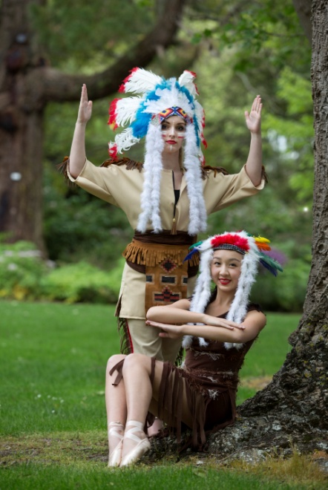Uniform Requirements

All items are available from **SUGAR PLUM FAIRY SHOP**—TERRACE END. **Hair must be** **up** for all classes except Contemporary at times. **Hair must be in a bun for Ballet from Grade 4 upwards please.** Crossover wraps are optional.

**\*TWINKLE TOES/FANCY FEET/DANCING DOTS-**Own leotard and skirt or fairy dress. Ballet shoes needed.

\***PRE PRIMARY/PRIMARY BALLET-** Pink capped sleeved leotard (Chloe) and pink chiffon short wrap skirt with socks/ballet stockings and ballet shoes with elastic. \***GRADE 1 AND 2 BALLET-** Pale blue leotard (Aimee) with ballet stockings and ballet shoes with elastic. Character skirt (3 blue ribbons preferred) and low heeled character shoes. \***GRADE 3 & 4 BALLET – NEW MAUVE LEOTARD (Sugar plum have specifications)** with ballet stockings and ballet shoes with ribbons. Character skirt and Cuban heeled Character shoes.

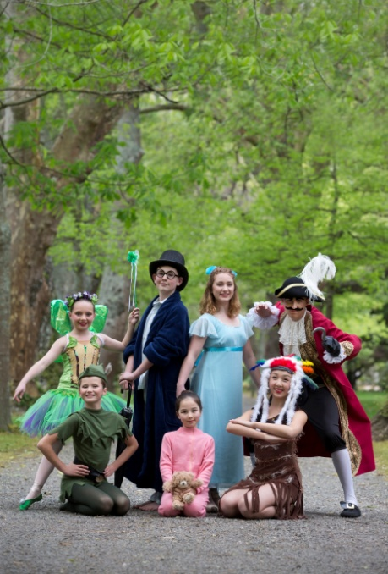**\*GRADE 5 BALLET-** Navy leotard (Faith) with ballet stockings and ballet shoes with ribbons. Character skirt and Cuban heeled Character shoes. \***HIGHER GRADES/VOCATIONAL BALLET-** Navy/black shoestring strapped leotard. Ballet flats and pointe shoes (you will be instructed on when to get your pointe shoes). Character gear for higher grades. Demi-pointes as Miss Maxene tells you. \***BEGINNERS (Primary)—GRADE 3 MODERN JAZZ—**Long sleeved leotard (purple, turquiose, royal blue or red—own choice) Black nylon lycra leggings. Jazz shoes needed from Grade 3+

**\* Boys only –** Personalised singlets can be purchased later in the year. Black shorts. Jazz shoes from Grade 3+ . Long black sport pants higher levels. \***GRADE 4- 6 AND VOCATIONAL MODERN JAZZ—** Black leotard any style. Black nylon lycra leggings and black Jazz shoes. \***BEGINNERS- GRADE 1 TAP—**Own leotard and skirt. Socks and Tap shoes. \***GRADE 2 TAP UPWARDS-** Black bootleg pants with own leotard/singlet top. Tap shoes—Oxford style from Grade 5 upwards. \***CONTEMPORARY–** Black leotard and leggings \***HIP HOP 9+ CLASSES–** Clothes that are easy to move in. Singlets can be purchased later in the year. **No Jeans.** Sneakers for Hip Hop.

***PLEASE REMEMBER FURTHER INFORMATION CAN BE FOUND AT www.maximumdance.co.nz***

IMPORTANT DATES FOR 2016:

NB: dates are subject to change. SS= Selected students.

*C:\Users\Max\AppData\Local\Microsoft\Windows\Temporary Internet Files\Content.IE5\N9S58UDZ\MC900171843[1].wmf ‘SIZZLING SUMMER DANCE DAYS’ 27th, 28th and 29th of JANUARY 8.45- 3pm.

*Enrolment day/Second hand uniform sale: Saturday 30th of January 10am- 1PM – Studio 1: 46 Victoria Ave.

*WEDNESDAY 3RD FEBRUARY : MDZ HIP HOP CREWE’S **AUDITIONS**- STUDIO 2- 188 CUBA ST. JUNIORS CREW 4.15 – 5PM SENIORS CREW 12 YRS +. 6PM-6.45.

Term one starts:

*Vocationals timetable begins 1st of February

* 8th February will be first full week for all classes.

*21st February - Esplanade open day:

**No classes** Good Friday or Easter Monday.

*15th April : NZAMD exams closing date

End of term one: Saturday 16th April.

*Manawatu competitions - 17th- 22nd April

*NZAMD Contemporary and hip hop exam students extra practices during the holidays TBC.

Term two starts: 2ND May

*RAD Vocational Ballet exam closing date: Wednesday 4th April

*RAD Grades Ballet exam closing date: Wednesday 25th May

*NZAMD Contemporary and Hip hop exams: 22nd June- 8th July

*RAD Vocational Ballet students Winter school in Wellington: TBC

*RAD grades, ISTD Tap and Modern examination coaching week/s: July holidays TBC

Term three starts: 25th July

*RAD Vocational Ballet exams: 1st – 6th August

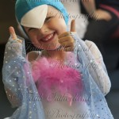*RAD Ballet Grade exams: 23rd August-13th September

*ISTD Modern and Tap exams – dates tba

End of term -24th September

Term four starts: 10th of October

*Recital 25th and 26th of November

*Free Workshop – 29th November

*Christmas break-up 30th Nov

* Senior’s break-up1st of December

Please check the website for the new timetable & fees for 2016.

*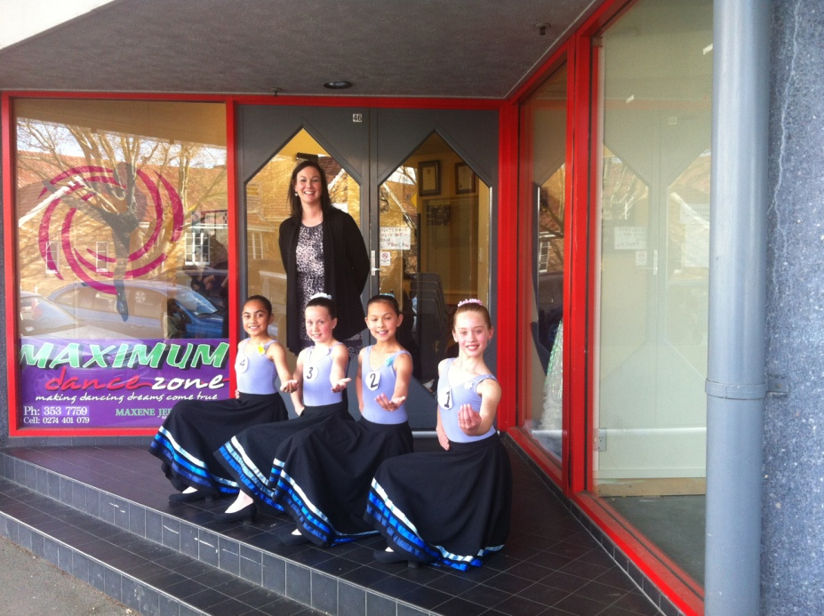 Looking forward to helping you reach for the stars!*

**Maxene Jeffares-Greer B.ED, DIP TCHG.**

Registered teacher Royal Academy of Dancing, Imperial Society and NZAMD. AISTD Dip Modern, AISTD Dip Tap (Dist). Teaching Certificate RAD, Teaching Diploma RAD (Dist). Former International Professional dancer, National adjudicator.

and staff—**Chanel Saunders**  (Associate Dip AISTD) **Jo Berrett** (NZAMD Solo Jazz, Hip hop and Contemporary, G8 RAD) **Kristina Beddis** (Associate ISTD Tap-Dist) **Sarah MacDonald** RAD Tchg cert **Emma Carey** (NZAMD Solo Contemporary G8 RAD Ballet, Adv 1 ISTD Mod, Adv 1 RAD Ballet) **Chantelle Christensen** Adv 2 RAD Ballet **Madeline McHardy** ISTD Intermediate Modern, L4 Contemp, G6 RAD Ballet.

Assistant and relieving Teachers: **Brianna Searle** Hip Hop L5, Inter ISTD Modern. Contemp L4 **Marian Sun** Grade 8 RAD Ballet Dist. Intermediate ISTD Modern, L4 Contemp, Hip Hop L5, Adv 1 ISTD Tap Dist **India Bos** Inter Found RAD Ballet **Bailee McConnell** Inter Found RAD Ballet, Inter Found ISTD Modern