RAD BALLET EXAM UNIFORM REQUIREMENTS
PRE PRIMARY & PRIMARY BALLET
Pink capped sleeved leotard (regulation – Chloe style), wrap chiffon skirt (regulation). Ballet socks and Ballet shoes with elastic. Hair: 2 plaits clipped across top of the head. NO make up, tattoos or knickers under leotards.
We will supply numbers and flowers etc for your hair.
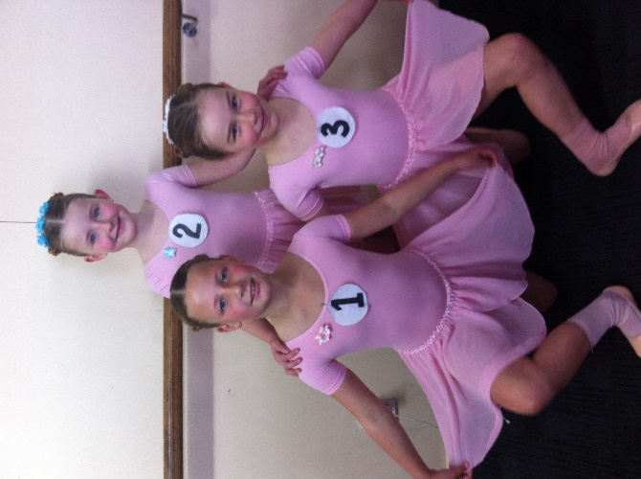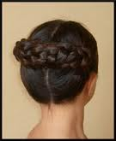
GRADE 1 AND 2 BALLET
Regulation pale blue, no sleeves leotard. Ballet stockings and shoes with elastic. Character skirt (with 3 ribbons). Low heeled character shoes. Hair: In a flat/smallish bun. NO make-up, tattoos or knickers under leotards.

GRADE 3 AND 4 BALLET
Regulation mauve, no sleeves leotard. Ballet stockings and shoes with ballet ribbons. Character skirt (with 3 ribbons). CUBAN heeled character shoes. No character shoes needed in Grade 4. Hair: In a flat/smallish bun. NO make-up, tattoos or knickers under leotards.
GRADE 5 BALLET
Regulation navy leotard (Faith), no sleeves leotard. Ballet stockings and shoes with ballet ribbons. Character skirt (with 3 ribbons). CUBAN heeled character shoes. Hair: In a flat/smallish bun. NO make-up, tattoos or knickers under leotards.
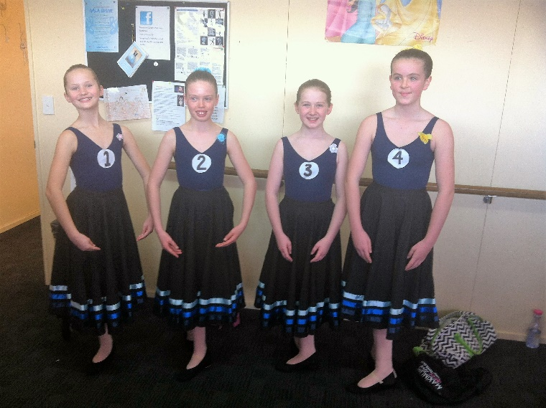
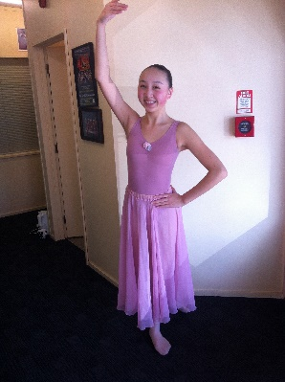
GRADE 6, 7 & 8 AWARD
Coloured leotard to match chiffon skirts (as discussed in class) Ballet stockings and shoes with ballet ribbons. Character skirt (with 3 ribbons). CUBAN heeled character shoes. Hair: In a flat/smallish bun. NO make-up, tattoos or knickers under leotards.

